My Portfolio(mrmimosizer.github.io)

Sites Audience

My Site is aimed at potential employers and thus I aimed to make both a technically and visually pleasing to the viewer.

To tackle this I aimed to accomplish a base wireframe that although ambitious was mostly tackled. My Sites audience would be looking for technical, visual and personality elements and thus I developed what you can view at mrmimosizer.github.io

Design Decisions

I kept two major features synonymous throughout the website which are the header which contains links to all pages and also the footer which contains basic contact information such as email, github and linkedin.

For my home page I displayed 3 columns of information, my picture so they know who to look for. A little information about me so they can understand the type of person I am and also some images to show what coding languages I know.

For my projects page I got a little more creative and have a rotating cube which shows some css skill and has clickable image links .I also have a tab’ed table that when a project name is clicked will give a brief description and also contains a solid button that links to my github

Usability Heuristics

I took the usability heuristics to mind when creating the website. I have made my website a more visually pleasing to the user and used English words instead of programming jargon.

Wireframes

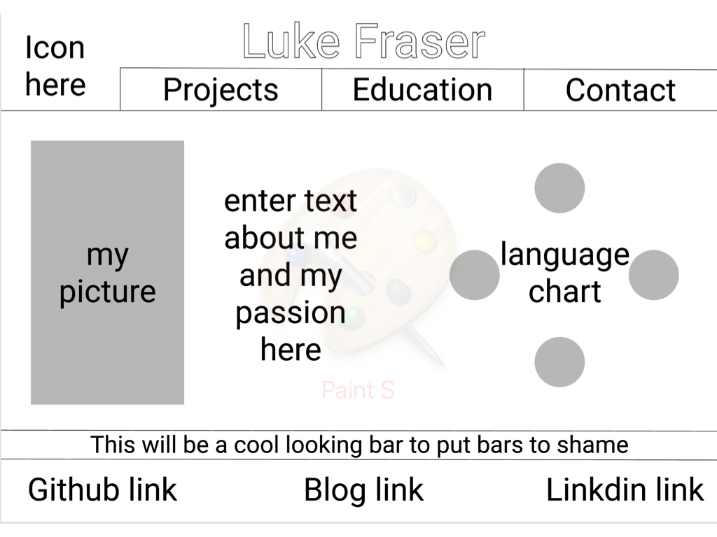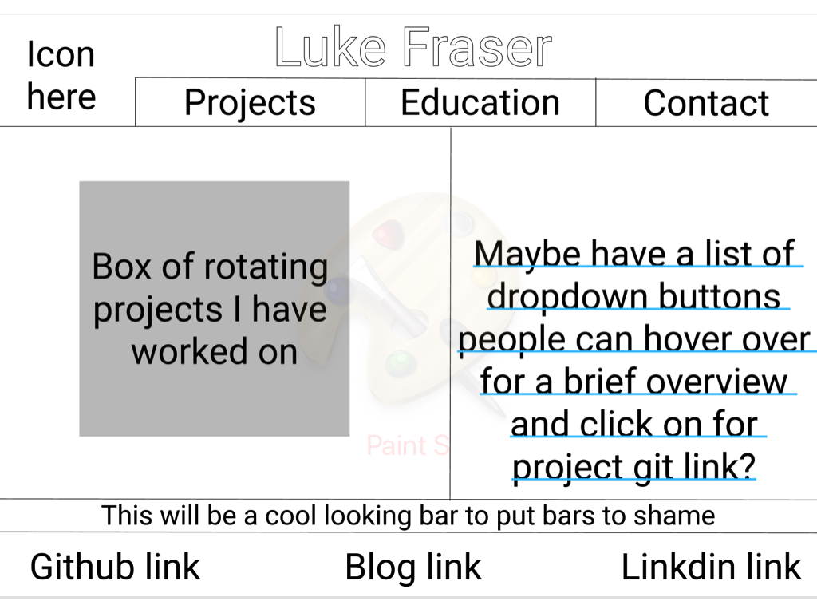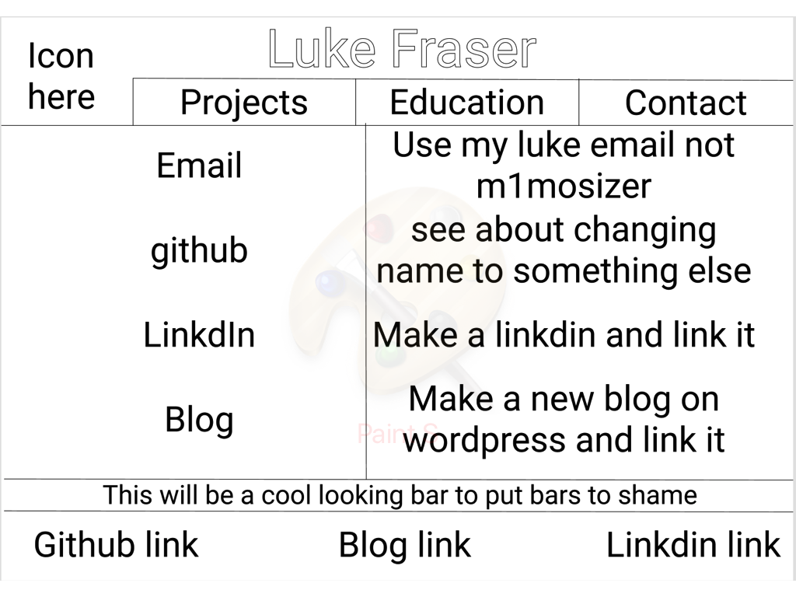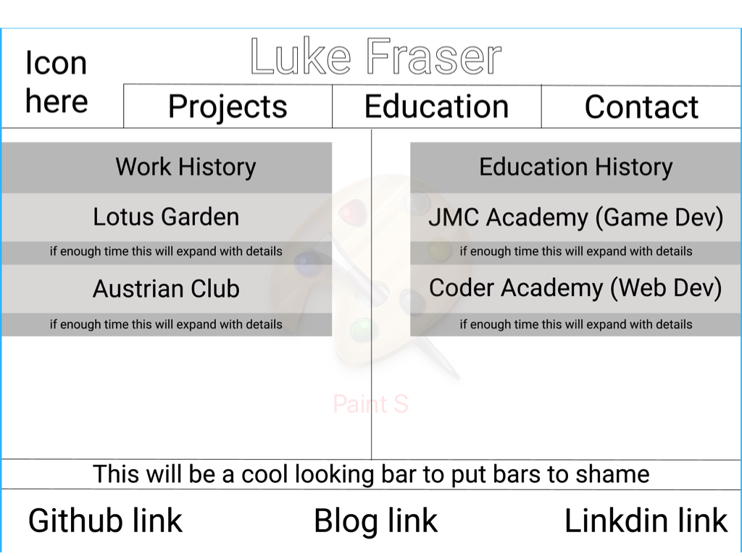

Personal Logo

